Article

Retinoic acid receptor alpha is essential in postnatal Sertoli cells, but not in germ cells.

**Diana Condrea 1,‡, Sirine Souali-Crespo 1,‡, Betty Féret 1, Muriel Klopfenstein 1, Sylvain Faisan 2, Manuel Mark 1,3, Norbert B. Ghyselinck 1, Nadège Vernet 1,\***

1 Institut de Génétique et de Biologie Moléculaire et Cellulaire (IGBMC), Département de Génétique Fonctionnelle et Cancer, Centre National de la Recherche Scientifique (CNRS, UMR7104), Institut National de la Santé et de la Recherche Médicale (INSERM U1258), Université de Strasbourg (UNISTRA), 1 rue Laurent Fries, 67404 Illkirch Cedex, France.

2 ICube (UMR 7357), Laboratoire des sciences de l'ingénieur, de l'informatique et de l'imagerie, UNISTRA, CNRS, 300 Boulevard Sébastien Brant, 67412 Illkirch Cedex, France.

3 Service de Biologie de la Reproduction, Hôpitaux Universitaires de Strasbourg (HUS), France.

‡ Equal first authors

**\*** Correspondence: [vernet@igbmc.fr](mailto:vernet@igbmc.fr)

**Table of contents**

I- Download data and code from GitHub

II- Install Python (and Numpy) on Windows

III- Visualize or edit Python files

IV- Run synchronization factor calculation using Python

I-Download data and code from GitHub

1. Go to the page <https://github.com/VernetNadege/Testis_Synchronization_Factor_Code>

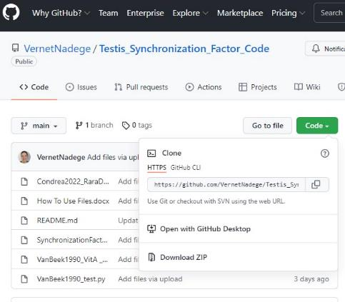

1. Download code using the Green Code command
2. Extract the zip files and save in a single folder

II-Install Python (and Numpy) on Windows

1. 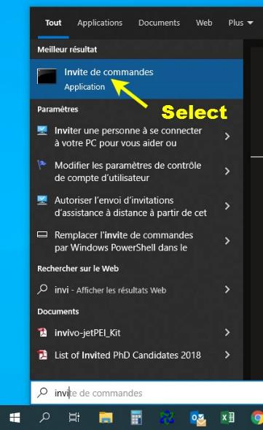Downlow and install package on <https://www.python.org/downloads/windows/>
2. Open Command Prompt (already pre-installed on Windows)
3. Install Numpy

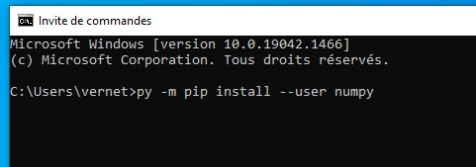

Enter **py -m pip install numpy** (user **with admin rights**)

Or

Enter **py -m pip install --user numpy** (user **without admin rights**)

* Collecting numpy and installation all done.

*Note: You should not open python but the IDLE Python to visualize/edit python files and the Command Prompt to run the code.*

*See below.*

--------------------------

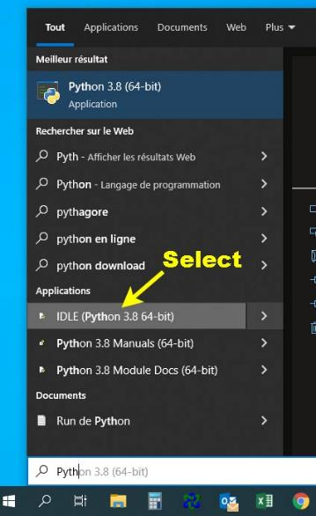III-Visualize or edit Python files

1. Open IDLE Python (installed with the Python package)
2. Open your file

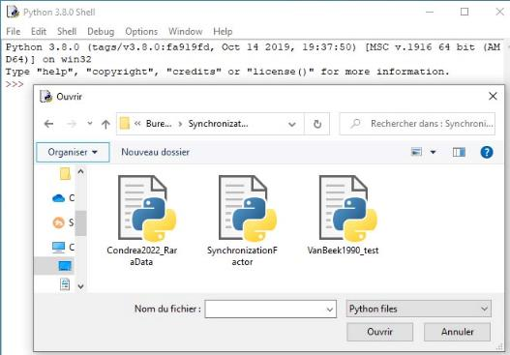File – Open – Go to your folder location (the .py files you downloaded from GitHub and saved in a same folder)

1. If you open Condrea2022_RaraData.py

This file contains data for RaraGerm+/+ RaraGerm-/- RaraD/L2 and RaraD/Germ- mice from Condrea et al Cells 2022 article

and what the software should display (print) after synchronization factor calculation.

1. If you open VanBeek1990_test.py

This file contains

* simplified data entry (WT1, WT2, WT3 and mutant) used to test synchronization factor software.
* percentages from Van Beek and Meistrich 1990 using rats post vitamin A (PVA) from Table1.

and what the software should display (print) after synchronization factor calculation.

*Note: Compare the Condrea et al. 2022 computed values for synchronization factor with the one obtained in Van Beek and Meistrich 1990 Table4.*

1. If you open SynchronizationFactor.py

This file contains the code for synchronization factor calculation.

This file should be in the same directory as the .py files containing the data.

You may use Condrea2022_RaraData.py as a template to enter and compute your own set of values.

--------------------------

IV-Run synchronization factor calculation using Python

Following files (downloaded from GitHub) are supposed to be in the same directory.

* Condrea2022_RaraData.py
* 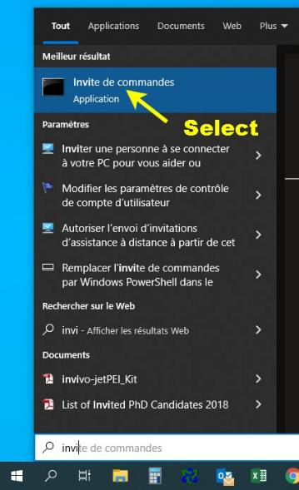VanBeek1990_test.py
* SynchronizationFactor.py

1. Open Command Prompt (tested with Python 3.8 and 3.10)
2. Find your directory (cd command)

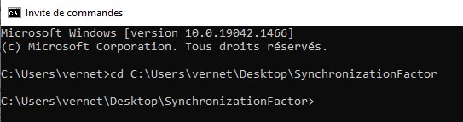

* + Type cd (space) link to your file folder *

(e.g. cd C:\Users\vernet\Desktop\SynchronizationFactor)

* + Enter

1. Run your python file (py command)

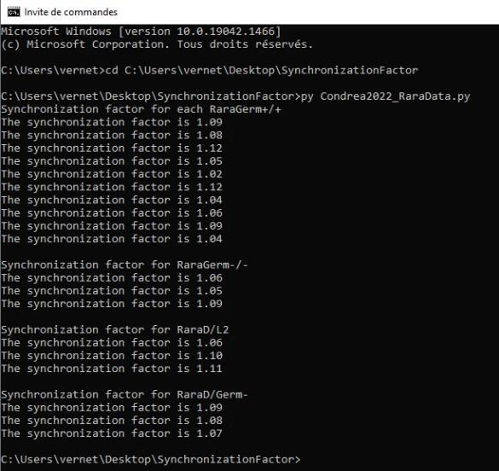

* How to find link to file folder (3) ** How to find file name (4)

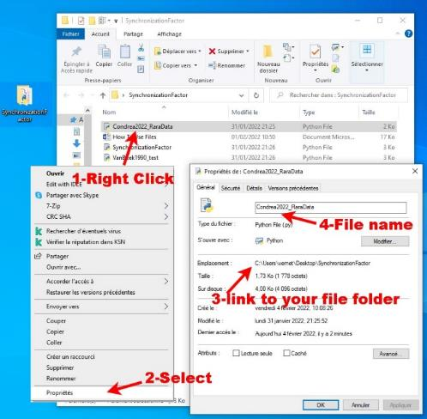

* + Type py (space) file name** with .py at the end

(e.g. py Condrea2022_RaraData.py)

* + Enter

Here you got the synchronization factor data.

*Note: Double click on the Condrea2022_RaraData.py file calculates synchronization factor but display briefly the results. Follow above instructions to visualize results.*